1. Documentation of functional and non-functional requirements
2. **Functional Requirements**

Listed below is a formal statement of our application’s functional requirements. They describe the core functionalities of our application, Investment portfolio trackers.

1. **The application allows user to create an account and log in with their account**
   1. The information needed for creating an account are:
      1. Customized User ID (have to be unique for each user)
      2. Password (consists of at least 11 characters, with a mix of numeric and alphabetical letters)
      3. Associated Email account (used to verify user identity & find back lost password)
      4. Security questions
   2. To log in to their account, user to input:
      1. User ID
      2. Password
   3. To find lost password, user to input either:
      1. Associated email account (to receive a link to reset password), or
      2. Reset password using security questions

1. **The application consists of a main portfolio page that allows the user to have an overview on the current portfolio & market performance; it also allows the user to click in to see the detailed information**
   1. Welcome Page (main page) is an overview of portfolio balance & performance, it consists of information on:
      1. Today’s Market Performance chart, which consists of current price, 1-day % change and 1-month % change for key market indicators such as:
         1. S&P 500
         2. NASDAQ
         3. Dow Jones
         4. 10-year Treasury yield
         5. DXY Index
         6. Hang Seng Index
      2. Portfolio overview chart, which covers the following information:
         1. Total value of each portfolio
         2. Total P/L of each portfolio
         3. Daily P/L of each portfolio
         4. A time series graph showing the change in total P/L overtime
      3. Total balance chart, which contains the following information:
         1. Total amount invested (in user’s preferred currency, default as SGD)
         2. Balance breakdown by the underlying currency of invested stocks
   2. For the “Portfolio overview” chart on the main welcome page, the user can click on each portfolio to view the details of the portfolio. When clicking on each portfolio in the chart, it will show a chart with all stocks within this portfolio, with the following information:
      1. Ticker & stock’s name
      2. Users’ average cost
      3. Current price level (in both user’s local currency & its original currency)
      4. Historical price changes: 1D, 1Y
      5. User’s total P/L with each stock
2. **The application also consists of “Individual stock page”, to allow the user to view the detailed information about individual stocks** 
   1. The “Individual stock page” can be accessed via:
      1. Through the main welcome page: “Portfolio overview” chart 🡪 click on individual portfolio (to display the chart with all stocks within the portfolio) 🡪 click on an individual stock. Within the “Individual stock page”, it will have the following information
      2. Through “watchlist”: User can click on any lines of stock information on Watchlist to access the respective” individual stock page” to view the more detailed information
   2. The “Individual stock page” consists of the following information:
      1. Basic information about the stock
         1. Ticker & name of the stock
         2. Current price level
         3. Real time price change
         4. Historical price changes: 1D, 5D, 1M, 3M, 1Y
         5. %IRR
         6. $EPS
         7. Key ratios: P/E Ratio, EV/EBITDA
      2. A price chart of the stock, with the following additional indicators
         1. 20-day moving average
         2. 90-day moving average
         3. 270-day moving average
      3. User’s P/L performance on this stock
         1. Total P/L with the stock (Realized & unrealized)
         2. Daily P/L with the stock (Unrealized)
         3. P/L time series chart
      4. Add/remove from watchlist
3. **The application allows user to key in their trade/transaction records** 
   1. To key in a transaction record, user to input:
      1. Transaction stock ticker (will show suggested tickers according to the first few letters, has to be a valid stock ticker)
      2. Transaction price
      3. Transaction quantity
      4. Transaction currency
      5. Transaction exchange rate
      6. Brokerage fee
      7. Portfolio it belongs to
   2. The transaction record will be automatically added to the user’s database, and the information on related pages will be updated (i.e., the main welcome page, and individual stock page)
4. **The application allows user to set investment profit target, and provides a financial calculator to provide investment guidance to achieve such profit target** 
   1. To set an investment target, user to input:
      1. Starting amount
      2. Expected return rate
   2. With the user’s input, it will calculate and show the user a suggested investment principal amount that the user should invest
5. **The application also consists of a “watchlist page”, which allows the user to select a group of securities to put on a “watchlist”, and closely monitor the performance of those securities** 
   1. The watchlist will display a chart which consists of basic information of all user-selected watchlist stocks, with the following information:
      1. Ticker & stock’s name
      2. Current price level
      3. Historical price changes: 1D, 1Y
      4. User’s total P/L with each stock
   2. When clicking on the individual lines of stock within the watchlist chart, it will direct the user to “Individual stock page” (see section 3 above) to view the detailed information about the stock
   3. The watchlist page also consists of a “search” function, which allows the user to search for any stocks to add or remove from their watch list
6. **Non-Functional requirements**
   1. Performance requirements
      1. The Welcome page must load within 3 seconds after opening the website.
      2. When logging in, users must be able to access the next page within 3 seconds after the correct account login details have been entered.
      3. Upon missing login input, the error message must be displayed and the input box must be highlighted in red within 1 second.
      4. Upon failed login attempt, the error message must be displayed and the input box must be cleared within 1 second.
      5. On the main page, the static contents of the webpage must be loaded within 1 second as the user is scrolling through the page.
      6. After typing the stock’s name that is to be added to the portfolio, the website must be able to verify whether the stock’s name is valid within 3 seconds.
      7. The website must be able to display the updated portfolio within 3 seconds once the request of adding or removing the stock transaction is submitted.
      8. For the financial calculator functionality, the website must be able to give the correct result within 3 seconds after the correct inputs are submitted.
      9. When there are missing inputs for the financial calculator, the website must be able to highlight the input box in red within 1 second.
      10. When adding a stock to the watchlist, the watchlist page must be able to display the updated watchlist within 3 seconds.
   2. Security

The website does not require personal information such as the user’s actual full name and location, and sensitive information, such as credit card information, for the user to use the website.

* 1. Usability
     1. The font size of the app must be readable, which is of size 10pt and above, and the font style is clear and readable.
     2. The user interface must maintain considerable consistency throughout the different pages. This includes pages’ background, basic layout, and theme.
     3. After a user performs an action, informative feedback is given.
        1. After pressing a functional button, such as add, remove, or submit, a pop up message such as “removed stock” appears to inform the user that the stock has successfully been removed.
        2. When a user performs actions that cause an error, an error message pops up to inform the user.
     4. Error prevention, such as the autocomplete feature should be available when users enter a stock’s name.
  2. Reliability
     1. The calculation logic, such as addition of the users’ total stock value, must be 100% correct.
     2. The website must be able to preserve the user’s stock data after logging out of the website.
     3. The website must not allow a stock to be added if the stock’s name entered is invalid.
     4. A monthly check on the app should be done to fix any bugs that surfaced.
  3. Scalability
     1. The website must be able to perform even if the number of users using the website increases, and the number of stocks that each user has increases
     2. Adding features to the website must be possible without disrupting current functioning features.
  4. Compatibility

The website can be accessed from any browser that is connected to the internet.

1. Data Dictionary

| ***Term*** | ***Definition*** |
| --- | --- |
| Username | User’s registered login credentials:  (Email / Username/ Phone Number) |
| Password | User’s registered login credentials:  (Alphanumeric code with symbols min of 8 characters) |
| Login | Prompt to retrieve User’s portfolio and previous settings.  (Upon valid entry of Login credentials) |
| Sign-up | Link to new user/ portfolio registration.  (Directed to page of new account creation) |
| Ticker | Unique series of letters assigned to each security  (Universal identity to each stock  eg: NASDAQ:AAPL ) |
| Stock’s Name | Stock’s Name Based on the trading market  (Eg: APPLE) |
| Quantity | Quantity of stocks/shares in position currently. |
| Value | Last recorded price per share/stock.  (Based on previous trading day or updated Pre-Market trading values) |
| Cost | Cost of Stock Purchase. |
| % Change | % Change recorded since value of acquired position and current price. |
| $ Change | $ Change recorded since value of acquired position and current price. |
| CurrVal | Current value of stock based on quantities of active positions.  ( CurrVal = Quantity * Value ). |
| % IRR | Internal Rate of Return from individual stocks/shares.  [ % IRR = (Value – Cost)/(Cost) * 100 ] |
| $ EPS | Earnings per share observed from $ Change in stock values ( +ve or -ve ).  [ $ EPS = (CurrVal – Cost) ] |
| % UnRl_PnL | % Unrealised Profit and Loss from *existing* individual stocks/shares.  [ % UnRl_PnL = % IRR * Cost ] |
| $ UnRl_PnL | $ Unrealised Profit and Loss from *existing* individual stocks/shares.  [ $ UnRl_PnL = $ EPS *Quantity ] |
| % Rl_PnL | % Realised Profit and Loss from *sold* stocks/shares.  [ % Rl_PnL = % IRR * Cost ] |
| $ Rl_PnL | $ Realised Profit and Loss from *sold* stocks/shares. |
| Purchase Date | Date(s) of stock purchases. |
| Sold Date | Date(s) stocks were sold. |
| Transactions | Number of Transactions for each stock. |
| Position Days | Number of days since the purchase of a stock. |
| $ Average Cost | Average cost of shares or stock bought at different prices over time. |
| $ Exchange rate | $ Paid when buying or selling an individual stock. |
| $ Brokerage fee | Transaction or Brokerage costs (if any). |
| Dividend History | Records and analysis of previous issued Dividends. |
| Portfolio Cost | Cost or amount Invested into existing shares/ stocks.  [ Cost Price ] |
| Portfolio Value | Current Value of all existing shares/ stocks.  [ Portfolio Value = CurrVal ( All Stocks ) + Rl_PnL ( All Stocks ) ] |
| Portfolio ROR | Overall Portfolio’s Rate of Return currently, from all stocks combined  [ Portfolio ROR = (Portfolio Value – Portfolio Cost) / (Portfolio Cost) *100 ] |
| $ Portfolio Projection | $ Portfolio’s projected return in 1 year, 5 years or 10 years using the average of Portfolio’s ROR on an investment calculator. |
| Position Ratios | % Weightage of Individual stocks against the Portfolio. |

*we need to finalise all the terms used in the whole proposal

*check if features need to be added as well

1. Initial Use Case Model, consisting of Use Case diagram and Use Case Description

**Use Case DIagram**

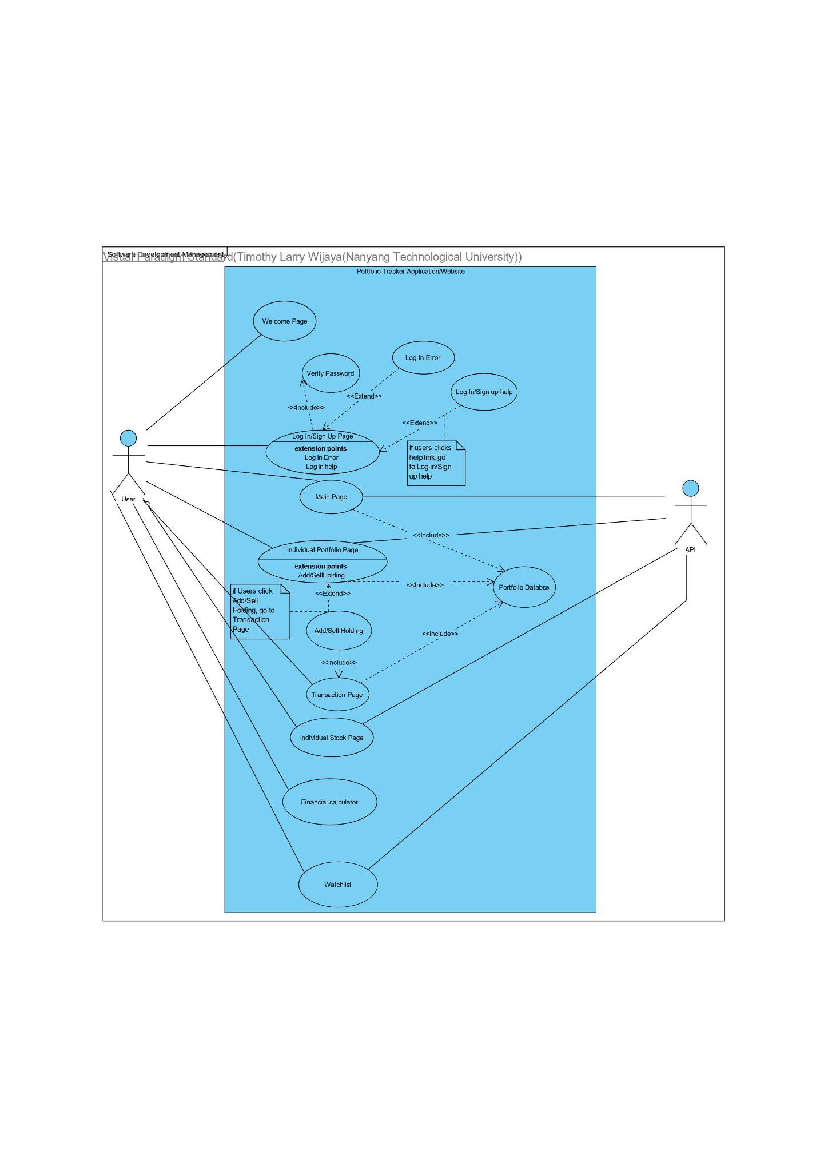

**Use Case Description**

1. **Welcome Page**

| Use Case ID: | UC001 | | |
| --- | --- | --- | --- |
| Use Case Name: | Welcome Page | | |
| Created By: |  | Last Updated By: |  |
| Date Created: |  | Date Last Updated |  |

| Actor: | User |
| --- | --- |
| Description: | The website that shows the introduction to our website. |
| Preconditions: | 1. Users must have an active internet connection |
| Postconditions: | 1. Users will be able to access the login/sign up page after clicking the respective buttons. |
| Priority: | Medium. Usually accessed by new users looking to sign up for a new account or users that just started using our application. |
| Frequency of Use: | Low. Users only need to use this website once every time they want to start using our application. |
| Flow of events: | 1. The user clicks onto your website link 2. The browser redirects the user to our welcome page 3. The user can click on either “login” or “sign up” button 4. The browser redirects the user to the respective pages that they intended to go to. |
| Alternative Flows: | - |
| Exceptions: | EX1: If there is no internet connection   * Redirection to next page fails |
| Includes: | - |
| Special  Requirements: | - |
| Assumptions: | - |
| Notes and issues: | - |

1. **Login/Sign Up Page**

| Use Case ID: | UC002 | | |
| --- | --- | --- | --- |
| Use Case Name: | Login Page | | |
| Created By: |  | Last Updated By: |  |
| Date Created: |  | Date Last Updated |  |

| Actor: | User |
| --- | --- |
| Description: | User uses their UserID and Password to Login |
| Preconditions: | 1. The user must have an active internet connection |
| Postconditions: | 1. The user would be able to access the full functionality of the application after logging in 2. All of user’s data is linked to their User ID |
| Priority: | High. The user must login before using any functionality of the application |
| Frequency of Use: | Low. The user only need to login once per use |
| Flow of events: | 1. The user press login/sign up button on the Welcome Page 2. The user will be shown this Login/Sign Up Page 3. The user can choose to login if they are already registered or to sign up if they are not previously registered 4. Once user login they will be shown the Main Page |
| Alternative Flows: | If the user does not log in, the full functionality of the application cannot be accessed. |
| Exceptions: | EX1: If there is no internet connection  1. Login attempts will fail. |
| Includes: | Password Verification |
| Special  Requirements: |  |
| Assumptions: |  |
| Notes and issues: |  |

1. **Main Page**

| Use Case ID: | UC003 | | |
| --- | --- | --- | --- |
| Use Case Name: | Main Page | | |
| Created By: |  | Last Updated By: |  |
| Date Created: |  | Date Last Updated |  |

| Actor: | Users |
| --- | --- |
| Description: | User can see the summary of all their portfolio and overall return across all portfolio |
| Preconditions: | 1. The user must have an active internet connection |
| Postconditions: | 1. The user is able to access his portfolio from this page |
| Priority: | High. The main page will give a quick overview on how the user’s portfolios are performing. It also gives access to all of the user’s portfolios. |
| Frequency of Use: | High. The users will always be directed to this page every time they login and will access this page to get a quick overview of users’ portfolio |
| Flow of events: | 1. The user get directed here after login or users press main page button 2. The user will get a quick overview of their portfolios 3. The user can select their portfolios to see them in detail |
| Alternative Flows: |  |
| Exceptions: |  |
| Includes: | Portfolio Database |
| Special  Requirements: |  |
| Assumptions: |  |
| Notes and issues: |  |

1. **Individual Portfolio Page**

| Use Case ID: | UC004 | | |
| --- | --- | --- | --- |
| Use Case Name: | Individual Portfolio Page | | |
| Created By: |  | Last Updated By: |  |
| Date Created: |  | Date Last Updated |  |

| Actor: | User |
| --- | --- |
| Description: | Users’ portfolios will be shown in detail. The details provided are stock average purchase price + cost, stock current value, stocks’ current gain/loss. Users’ will also be able to add/remove their stock holding. |
| Preconditions: | 1. The user must have an active internet connection 2. The user must press the specific portfolio they want to see in UC003 |
| Postconditions: | 1. The user can press add/remove transaction to go to UC005 |
| Priority: | High. The users will be able to see their stock performance and might use it to make decisions in changing their portfolio structure. |
| Frequency of Use: | High. The users will access this page often when they want to see their portfolio in detail and if they want to add/remove stock. |
| Flow of events: | 1. The user press the portfolio button in UC003 2. The user see their portfolio in detail 3. The user has option to add/remove stock |
| Alternative Flows: |  |
| Exceptions: |  |
| Includes: | Portfolio Database |
| Special  Requirements: |  |
| Assumptions: |  |
| Notes and issues: |  |

1. **Individual Stock Page**

| Use Case ID: | UC005 | | |
| --- | --- | --- | --- |
| Use Case Name: | Individual Stock Page | | |
| Created By: |  | Last Updated By: |  |
| Date Created: |  | Date Last Updated |  |

| Actor: | User |
| --- | --- |
| Description: | User’s specific stocks from their portfolios will be shown in detail. The details provided are stock average purchase price + cost, stock current value, stocks’ current gain/loss. |
| Preconditions: | 1. The user must have an active internet connection 2. The user must press the specific stock they want to see from their portfolio in UC004 |
| Postconditions: | 1. Users can press back to go back to their individual portfolio page in UC004 |
| Priority: | High. The users will be able to see their stock performance and might use it to make decisions in changing their portfolio structure. |
| Frequency of Use: | High. The users will access this page often when they want to see their stock in detail. |
| Flow of events: | 1. The user click on one of their stock tab in UC004 or from the search tab 2. The user see that specific stock in detail. |
| Alternative Flows: |  |
| Exceptions: |  |
| Includes: |  |
| Special  Requirements: |  |
| Assumptions: |  |
| Notes and issues: |  |

1. **Transaction Page**

| Use Case ID: | UC006 | | |
| --- | --- | --- | --- |
| Use Case Name: | Transaction Page | | |
| Created By: |  | Last Updated By: |  |
| Date Created: |  | Date Last Updated |  |

| Actor: | User |
| --- | --- |
| Description: | Users can enter their newly invested stocks into the transaction page |
| Preconditions: | 1. Users must have an active internet connection. 2. Users must click the add/delete button in UC004. |
| Postconditions: | 1. Users will be directed back to the portfolio page after adding/removing a transaction or cancelling the action |
| Priority: | High. Users must submit something on this page in order for them to update their portfolio. |
| Frequency of Use: | Medium. Users use this page when they want to add/remove a transaction from their portfolio. |
| Flow of events: | 1. The user clicks the add/remove button. 2. The user enters the relevant information. 3. The user clicks the confirm button to update their portfolio. 4. The user is redirected back to the portfolio page in UC004. |
| Alternative Flows: | 1. The user clicks the cancel/back button. 2. The user is redirected back to the portfolio page in UC004. |
| Exceptions: | - |
| Includes: | Portfolio Database |
| Special  Requirements: | - |
| Assumptions: | - |
| Notes and issues: | - |

1. **Financial Calculator**

| Use Case ID: | UC007 | | |
| --- | --- | --- | --- |
| Use Case Name: |  | | |
| Created By: |  | Last Updated By: |  |
| Date Created: |  | Date Last Updated: |  |

| Actor: | User |
| --- | --- |
| Description: | Users will be able to use this feature to calculate end amount, return needed or additional contribution needed to help them make their investment plan according to their goal. |
| Preconditions: | 1. Users must have an active internet connection. |
| Postconditions: | 1. The result from the calculation will be shown to him |
| Priority: | Medium. This is an extra feature to help users in their planning. |
| Frequency of Use: | Medium. Users will only access this page when they need help with the calculations for their planning |
| Flow of events: | 1. The user inserts inputs for the financial calculator 2. The calculator help to calculate 3. The calculator shows the result of the calculations |
| Alternative Flows: |  |
| Exceptions: | EX1: If users input input negative number  1. Calculator will fail |
| Includes: |  |
| Special  Requirements: |  |
| Assumptions: |  |
| Notes and issues: |  |

1. **Watchlist**

| Use Case ID: | UC008 | | |
| --- | --- | --- | --- |
| Use Case Name: | Watchlist | | |
| Created By: |  | Last Updated By: |  |
| Date Created: |  | Date Last Updated: |  |

| Actor: | User |
| --- | --- |
| Description: | Watchlist of all the stocks that users want to keep a lookout on. |
| Preconditions: | 1. Users must have an active internet connection. |
| Postconditions: | 1. Users’ updated watchlist will be shown |
| Priority: | Medium. Watchlist is an additional feature. Not all users will fully utilise this feature. |
| Frequency of Use: | Medium. Users will come to this page only if they want to add/remove from their watchlist. |
| Flow of events: | 1. The user clicks the add/remove button. 2. The user searches for their desired stock based on the company name or code. 3. The user clicks on the confirm button to update their watchlist. |
| Alternative Flows: | - |
| Exceptions: | - |
| Includes: | - |
| Special  Requirements: | - |
| Assumptions: | - |
| Notes and issues: | - |

1. UI mockups
2. **Welcome Page**



1. **Sign up & Login Page**

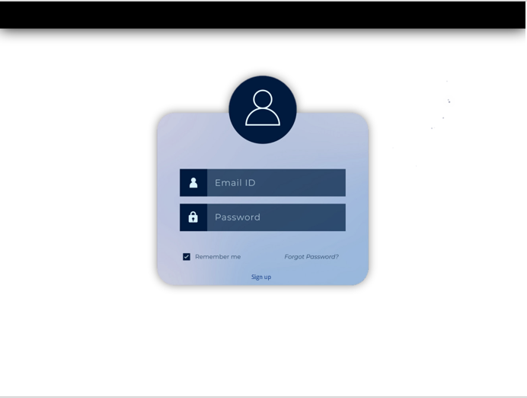

1. **Main/Portfolio Page**

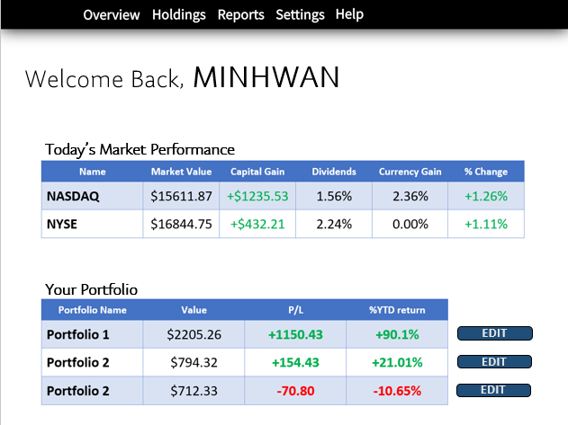

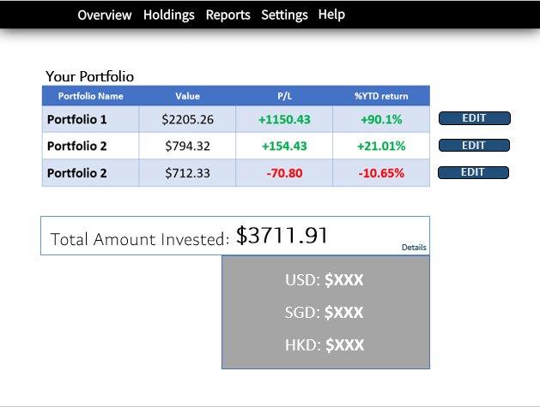

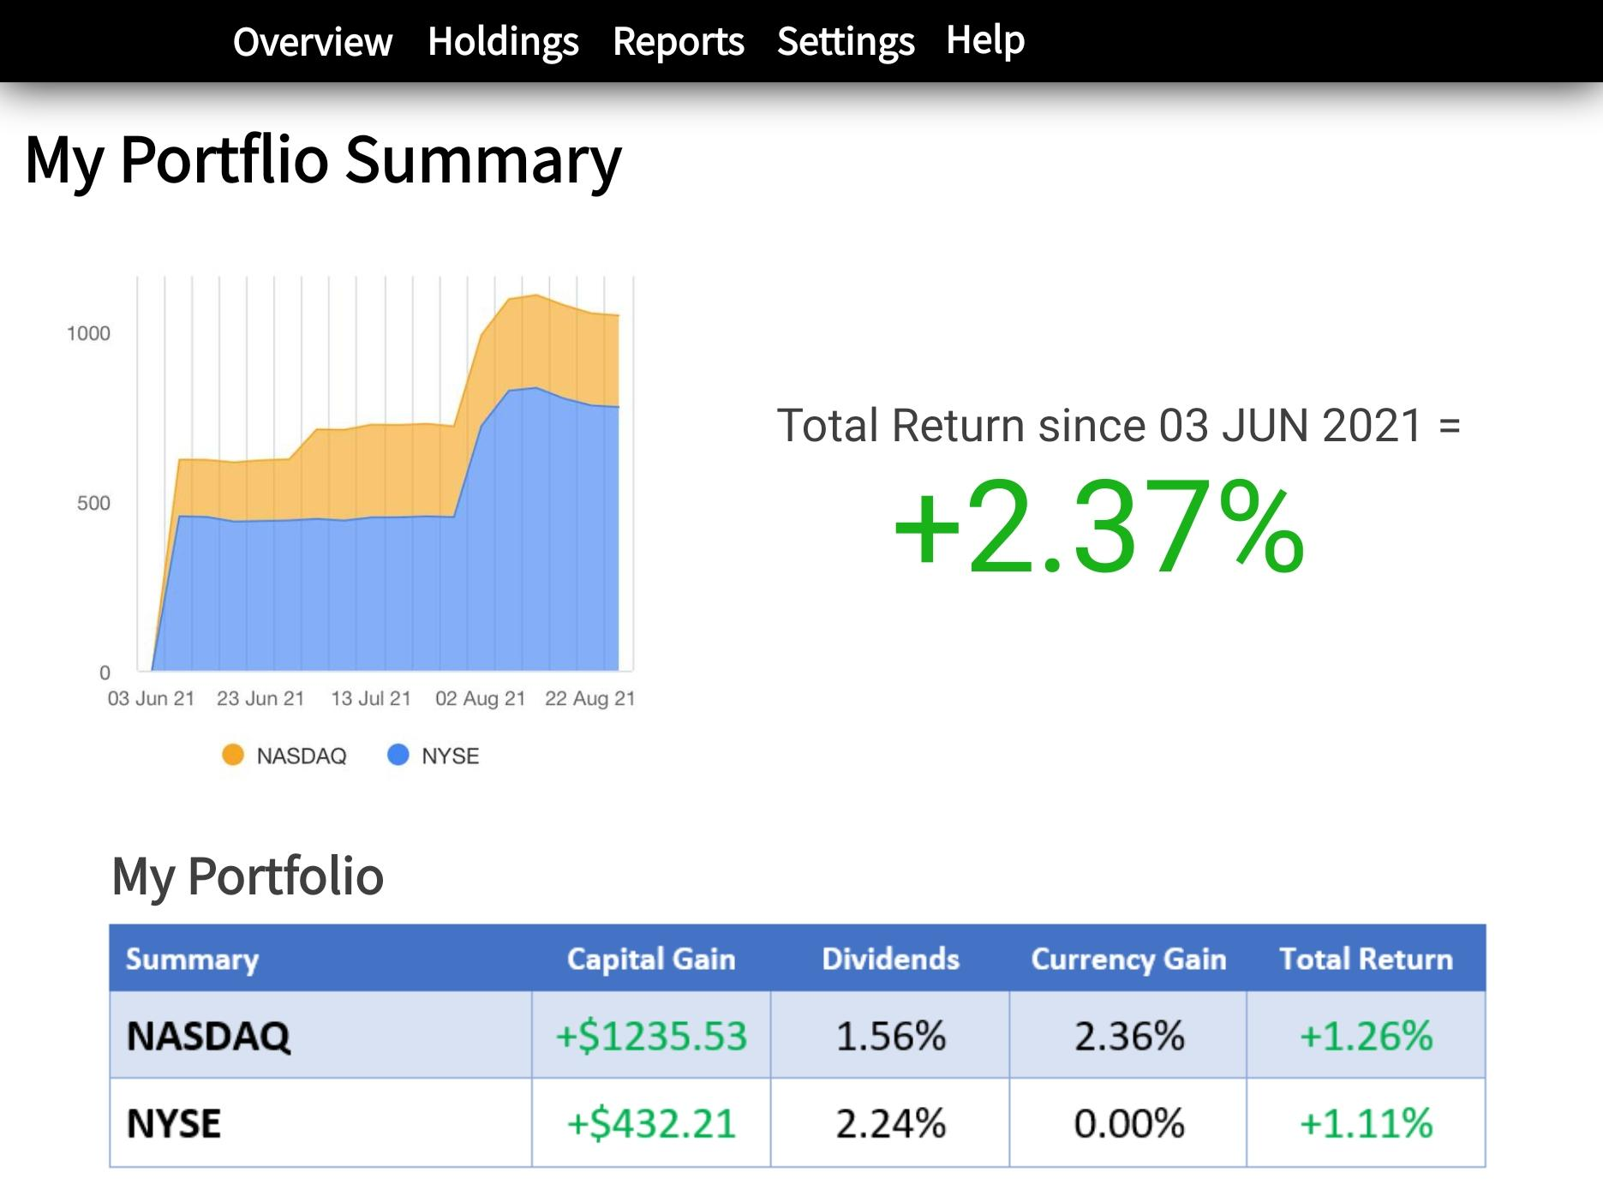

1. **Transaction Page**

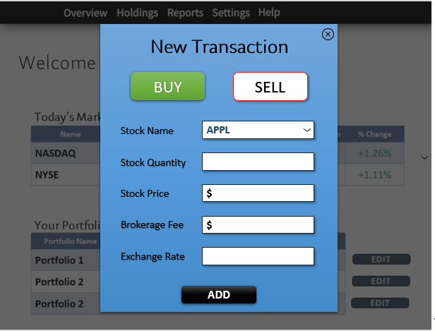

1. **Individual Stock Page**

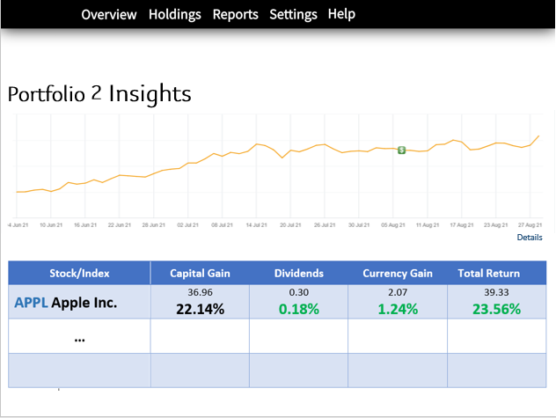

1. **Financial Calculator**

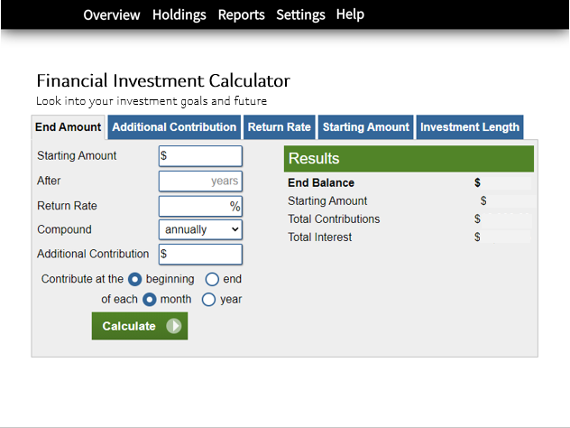

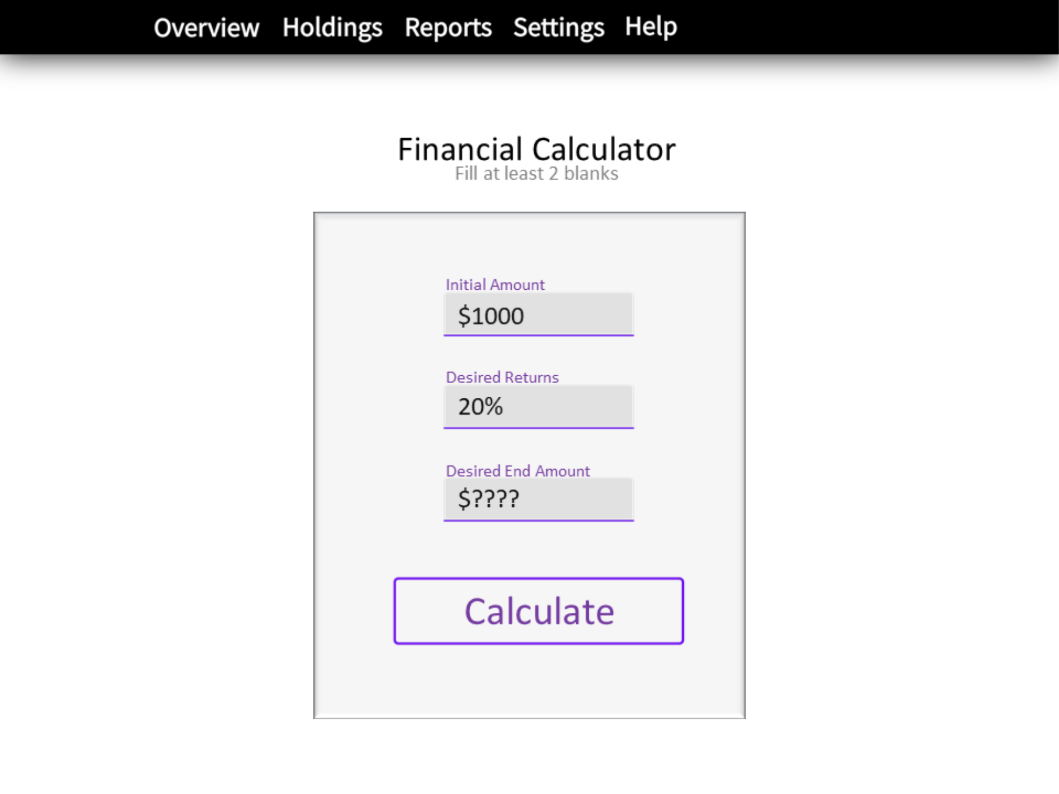

1. **Watchlist**

